Jonathan Long

Film und Fotografie – Stuttgart 1929

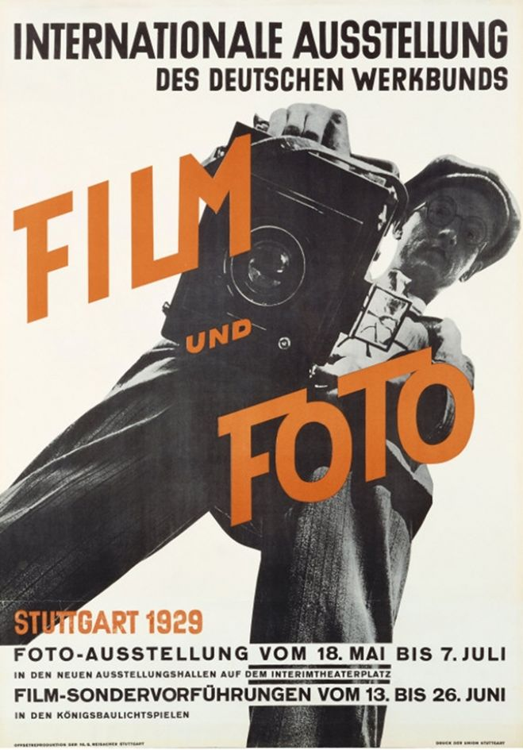

Illustration: http://www.moma.org/collection/object.php?object_id=6654

Film und Fotografie, known as FiFo, is shorthand for the Internationale Ausstellung des deutschen Werkbundes [International Exhibition of the German Werkbund], which opened in Stuttgart in May 1929. It presented an overview of contemporary photography, and is widely acknowledged as one of the most important photographic exhibitions of all time. The Werkbund was an open association – mainly consisting of architects but also involving craftsmen, industrialists, businessmen, publishers, and teachers – that supported training in the applied arts. Fifo was initiated by Gustav Stotz, director of the Württemberg section of the Werkbund, and its selection committee consisted of art historian Hans Hildebrandt, architect Bernhard Pankok, and typographer Jan Tschichold. Prominent photographers and critics were responsible for different sections of the exhibition: László Moholy-Nagy for Germany, Siegfried Giedion for Switzerland, El Lissitzky for the Soviet Union, Edward Steichen and Edward Weston for the United States, and Piet Zwart for the Netherlands. Hans Richter curated the accompanying film programme. After the Stuttgart show, the exhibition toured to Berlin and Wrocƚaw (formerly Breslau) and – under the title Das Lichtbild [The Photograph] – to Munich, Essen, and Dessau. In 1930, it was shown, in various guises, in Zurich, Vienna, Gdansk (formerly Danzig), Zagreb, Tokyo and Osaka.

Rather than being displayed thematically or hierarchically by genre (that is, as “fine art”), the exhibits in FiFo were organised according to the name, country, or professional affiliation of the photographer, with such affiliations including press agencies and Germany’s major schools of applied art. The exhibition was inclusive in ethos, displaying photomontages and photographs from the fields of journalism, book design, propaganda, science, and advertising. Emphasis was thus laid less on photography’s status as a fine art than on the formal techniques associated with the Neues Sehen [New Vision], a loose term for an approach to photography that sought to renew and extend human perception by defamiliarising the object world. In line with the pedagogical aims of the Werkbund, FiFo was thus to an extent didactic: it sought to promulgate the ideology of photographic modernism in both its pure and applied guises, an aim that was supported by three books published in connection with the exhibition: the catalogue edited by Karl Steinorth; Roh and Tschichold’s *Foto-Auge*, and Roh’s *László* *Moholy-Nagy: 60 Fotos*. The fact that FiFo presented avant-garde and modernist photography throughout Germany, central Europe, and Japan is often seen as testament to its exceptional success in disseminating the most advanced photography to a wide global audience. Critics of the exhibition, however, maintain that it marks the taming or domestication of the avant-garde. The Neues Sehen was initially animated by utopian impulses, with the renewal of perception by photography forming part of a more general rebuilding of social life in which art was to play a central role. FiFo, on the other hand, divorced contemporary photography from any programme of social action. The exhibition’s manifest investment in technique, technology, and novelty was, in the eyes of its detractors, fully in tune with with the very values of industrial capitalism that the avant-garde had subjected to critique.

References

Steinorth, K. (1929) Internationale Ausstellung des Deutschen Werkbundes. Film und Foto Stuttgart: .

Roh, F., and J. Tschichold (1929) Foto-Auge, Stuttgart: Akademischer Verlag Dr Fritz Wedekind und Co

Roh, F. (1930) László Moholy-Nagy: 60 Fotos, Berlin:

Margolin, V. (1997) The Struggle for Utopia: Rodchenko, Lissitzky, Moholy-Nagy 1917-1946, Chicago: University of Chicago Press

Eskildsen, U. and J.-C. Horak (1979) Film und Foto der zwanziger Jahre: Eine Betrachtung des Internatinalen Werkbundausstellung ‘Film und Foto’, Stuttgart: Württembergischer Kunstverein.

Roters, E., and B Schultz (1995) Stationen der Moderne, Berlin: Ars Nicolai

Hight, E. (1995) Picturing Modernism: Moholy-Nagy and Photography in Weimar Germany, Cambridge MA: MIT Press